

FoodShare Connect
Food Donation and Distribution Management System
CAPSTONE PROJECT REPORT
A Capstone Project Report submitted in partial fulfilment of the requirements
for the Course of
CSA4308 – INTERNET PROGRAMMING
to the award of the degree of
BACHELOR OF TECHNOLOGY IN
COMPUTER SCIENCE AND ENGINEERING
Submitted by
G VENKATESH REDDY (192372262)
Under the Supervision of
RAJAGOPAL K
SIMATS ENGINEERING
Saveetha Institute of Medical and Technical Sciences
Chennai-602105
SEPTEMBER 2026

SIMATS ENGINEERING
Saveetha Institute of Medical and Technical Sciences Chennai-602105

BONAFIDE CERTIFICATE

This is to certify that the Capstone Project entitled “FoodShare Connect – Food Donation and Distribution Management System” has been carried out by G Venkatesh Reddy (192372262) under the supervision of Mr. Rajagopal K and is submitted in partial fulfilment of the requirements for the current semester of the B.Tech COMPUTER SCIENCE AND ENGINEERING program at Saveetha Institute of Medical and Technical Sciences, Chennai.

COURSE COORDINATOR COURSE FACULTY
Dr Anusuya, RAJAGOPAL K,
Program Director Professor - Programming
CSE CSE
SIMATS Engineering, SIMATS Engineering,
SIMATS, Chennai – 602105. SIMATS, Chennai – 602105.

SIMATS ENGINEERING
Saveetha Institute of Medical and Technical Sciences Chennai-602105

DECLARATION

I G Venkatesh Reddy of the CSE SIMATS Engineering, Saveetha Institute of Medical and Technical Sciences, Chennai, hereby declare that the Capstone Project Work entitled “FoodShare Connect – Food Donation and Distribution Management System” is the result of our own bonafide efforts. To the best of our knowledge, the work presented herein is original, accurate, and has been carried out in accordance with the principles of engineering ethics and academic integrity. All sources, references, data, and other materials used in the project have been appropriately acknowledged. We further declare that the data, results, analysis, and findings presented in this report have not been fabricated, falsified, or manipulated. Any external tools, software, datasets, computational resources, or AI-assisted tools used during the project have been appropriately disclosed. We confirm that all applicable ethical, academic, institutional, and professional requirements have been duly followed throughout the planning, execution, analysis, and documentation of the project.

Place:CHENNAI
Date:9/2/2026

Signature of the Student with Names

SIMATS ENGINEERING
Saveetha Institute of Medical and Technical Sciences Chennai-602105

Individual Contribution Statement

Student Name / Register No. | Specific Responsibilities | Design & Development Contribution | Testing & Analysis Contribution | Report Contribution | Approx. Contribution (%)
K Sai Kumar (192365025) | System planning, architecture, database/data model, food-waste tracking, workflow analysis and testing. | Chapters 1, 3 and 4; architecture, calculations, testing and technical appendices. | 20% | Report Contribution | Approx. Contribution (%)
Kongara Sai (192365025) | User interface, authentication, navigation and usability support. | Chapters 2 and 4; interface discussion, login/registration evidence and usability notes. | 20% | Report Contribution | Approx. Contribution (%)
B Yogendra (192325046) | Donor dashboard, food donation entry, inventory records and status tracking. | Chapters 3 and 4; donor workflow, screenshots, testing and inventory analysis. | 20% | Report Contribution | Approx. Contribution (%)
G Venkatesh Reddy (192372262) | NGO browsing, request workflow, quantity matching and allocation analysis. | Chapters 3 and 4; request workflow, calculation and technical appendices. | 20% | Report Contribution | Approx. Contribution (%)
H Sanjay Reddy (192372056) | Administrator workflow, testing, documentation consolidation and final review. | Chapters 4 and 5; admin screenshot, testing, conclusion and contribution evidence. | 20% | Report Contribution | Approx. Contribution (%)

ABSTRACT

Food waste is a significant engineering and operational challenge because surplus food generated by restaurants, hotels, institutions, events, and other food-service organizations is often difficult to identify, record, redistribute, and monitor before it becomes unusable. Existing practices frequently depend on manual recording, disconnected communication channels, and delayed coordination between food donors and potential recipients. These limitations can result in poor visibility of available surplus food, inefficient distribution, avoidable wastage, and difficulty in maintaining reliable records.

The FoodShare Connect – Food Donation and Distribution Management System is proposed to provide a centralized digital platform for recording surplus food and coordinating its distribution to suitable recipients. The system is designed to use cloud-based data storage and application services to maintain information related to food quantity, category, availability, location, donor details, recipient requirements, and distribution status. The proposed workflow enables authorized users to register surplus food, monitor available donations, identify suitable distribution opportunities, and update the status of each food item throughout the process.

The methodology involves requirement analysis, system architecture design, database design, user-interface development, cloud integration, module integration, and functional testing. The system is organized into interconnected modules for food-waste registration, cloud data management, donation tracking, recipient/distribution management, and monitoring. Testing is performed to verify data entry, storage, retrieval, user workflows, and successful coordination between the major system components.

The developed prototype is intended to demonstrate improved visibility and traceability of surplus food compared with manual tracking approaches. The supplied evidence confirms the main functional workflow across donor, NGO and administrator screens. No measured response-time, throughput, accuracy percentage or processing-time reduction is claimed because those metrics were not instrumented in the supplied project evidence. The evaluation therefore focuses on functional verification and consistency of the demonstrated records.

Overall, the project demonstrates how cloud-based technologies can support a more organized, traceable, and scalable approach to food-waste management and surplus-food distribution. The proposed system provides a foundation for future integration of intelligent.

TABLE OF CONTENTS

i | CERTIFICATE FROM THE SUPERVISOR | 4
ii | DECLARATION BY THE CANDIDATE | 5
Iii | INDIVIDUAL CONTRIBUTION STATEMENT | 6
iv | ABSTRACT | 7
v | LIST OF FIGURES | 10
vi | LIST OF TABLES | 11
vii | LIST OF ABBREVIATIONS | 12
1 | CHAPTER 1: Introduction | 13
2 | CHAPTER 2: Literature Review | 16
3 | CHAPTER 3: Engineering Design & Trade-offs, Sustainability, Ethics, Safety, Risk & Security | 18
4 | CHAPTER 4: Implementation, Testing & Results, Project Management | 23
5 | CHAPTER 5: Conclusion & Reflection | 28
 | References | 30
A | Appendix A – Detailed Calculations | 31
B | Appendix B – Engineering Drawings / Schematics | 31
C | Appendix C – Source Code / Code Repository Information | 32
D | Appendix D – Datasheets | 33
E | Appendix E – Experimental / Raw Data | 34
F | Appendix F – Ethics / Institutional Approval | 34
G | Appendix G – Project Meeting / Progress Records | 35
H | Appendix H – User / Industry Feedback | 35
I | Appendix I – Publications / Patents / Competitions / Product Outcomes | 36
J | Appendix J – Individual Contribution Evidence | 36

LIST OF FIGURES

Figure No. | Figure Name | Page No.
Fig. 1 | FoodShare Connect System Architecture | 20
Fig. 2 | FoodShare Connect Workflow | 20
Fig. 3 | Login Screen | 23
Fig. 4 | Donor Dashboard | 24
Fig. 5 | NGO Request Queue | 24
Fig. 6 | NGO Browse Available Food | 24
Fig. 7 | Registration and Role Selection | 25

LIST OF TABLES

Table No. | Table Name | Page No.
1 | Existing Approach Comparison | 17
2 | Stakeholder Requirements | 18
3 | Functional and Non-Functional Requirements | 18
4 | Standards and Codes | 18
5 | Design Specifications | 18
6 | Alternative Solutions Evaluation | 19
7 | Selected Design Decision | 21
8 | Sustainability, Ethics, Safety & Security Considerations | 22
9 | Risk Register | 22
10 | Tools / Software / Equipment | 23
11 | Test Plan & Verification | 25
12 | Objective Achievement | 27
13 | Project Roles & Contributions | 28
14 | Capstone Project Outcome Mapping | 36

LIST OF ABBREVIATIONS / SYMBOLS

Symbol | Description | Unit
Q_available | Quantity currently available | packets/items
Q_request | Quantity requested by NGO | packets/items
Q_remaining | Quantity remaining after full approved allocation | packets/items

CHAPTER 1

INTRODUCTION AND ENGINEERING PROBLEM

  - Background

Food waste is an engineering and coordination problem as much as a social problem. Surplus meals can remain usable for only a short period, while donors, NGOs and volunteers often work with different information and schedules. FoodShare Connect addresses this coordination gap through a role-based web application that records available food, exposes it to eligible NGOs, and gives an administrator a controlled request and allocation workflow. The prototype is designed around a cloud-ready architecture so that the same logical workflow can be deployed on hosted infrastructure when required.

  - Need for the Project

The need is driven by the mismatch between the time-sensitive nature of surplus food and the slower, fragmented nature of manual coordination. A usable engineering solution must keep food records visible, prevent avoidable duplicate allocation, support multiple user roles, and maintain a traceable request state from donation to distribution.

    - Why the problem needs to be addressed
    - Who is affected by the problem
    - Existing limitations
    - Engineering significance

  - Problem Statement

Design and implement a reliable, secure and maintainable digital system that can capture surplus-food donations, expose currently available inventory to NGOs, accept food requests, and allow an administrator to review and control allocation. The problem involves interacting constraints: food availability changes over time, requests may compete for the same inventory, users have different permissions, and the system must remain simple enough for practical use while maintaining traceability and data consistency.
    - Multiple interacting factors: inventory quantity, request quantity, food availability, location, user role and time.
    - Technical complexity: role-based access, database state changes, request approval and inventory consistency.
    - Conflicting requirements: fast user interaction versus controlled approval; simplicity versus auditability.
    - Realistic constraints: limited prototype resources, local demonstration environment, food-safety dependency on users, and no measured production-scale load test.

  - Project Aim

To develop a cloud-ready food-surplus tracking and distribution platform that improves visibility, coordination and traceability between donors, NGOs, volunteers and administrators.

  - Project Objectives
- To design a role-based architecture for donor, NGO, volunteer and administrator workflows.
- To develop modules for registration, donation entry, food browsing, requests and administrative review.
- To model food inventory and request states so that each transaction has a clear status.
- To implement the prototype using a web application and database-backed workflow.
- To test the major user journeys using functional verification scenarios.
- To evaluate the prototype against usability, traceability, security and scalability requirements.

  - Scope

Scope: the project defines what is included, excluded, assumed and treated as a prototype boundary condition, as detailed in the following points.

    - Included: user registration and role selection, donation recording, available-food browsing, NGO requests, administrator approval/rejection, and status tracking.
    - Excluded from the supplied prototype evidence: production payment processing, automated food-quality sensors, GPS route optimization, biometric identity verification, and independently verified production performance benchmarks.
    - Assumptions: users enter truthful food and quantity information; administrators review requests; the database is reachable; and food is distributed within applicable safety guidance.
    - Boundary conditions: the demonstrated build is a local web prototype, while the logical architecture is cloud-ready; actual deployment, security audit and load testing are outside the supplied evidence.

  - Expected Engineering Outcome

The intended engineering outcome is a working prototype and a documented system design that can be deployed as a cloud-hosted service. It is a software infrastructure solution rather than a hardware device.

    - System: role-based food donation and distribution workflow.
    - Product: FoodShare Connect web application.
    - Process: donate → browse → request → approve/reject → collect/distribute.
    - Prototype: locally demonstrated application with database-backed screens.
    - Algorithm: inventory allocation check based on available quantity and requested quantity.
    - Model: food and request state model with auditable status changes.
    - Device: no dedicated hardware is required for the prototype.
    - Infrastructure: cloud-ready web/database deployment architecture.

CHAPTER 2

LITERATURE REVIEW AND EXISTING SOLUTIONS

  - Review Method

The review considered food-waste statistics and guidance, existing food-rescue platforms, cloud-computing principles, application-security guidance, software-quality standards and food-safety regulations. Sources were selected for direct relevance to the system requirements: traceability, role separation, reliable data handling, scalability, security and safe handling of surplus food.

  - Review of Existing Work

The reviewed approaches fall into four useful groups: manual/community coordination, food-rescue platforms, cloud information systems, and secure software-development guidance. Manual approaches are inexpensive but provide weak traceability. Food-rescue platforms demonstrate the value of matching donors and recipients, but their workflows may not expose the same administrative controls required for this academic prototype. Cloud systems provide centralized data access and scalability, while security and quality standards provide the engineering controls needed to make the application dependable.

    - Research papers and technical literature: used to understand food-waste reduction, digital coordination and sustainable information systems.
    - Existing systems: food-rescue and donation platforms were examined as reference models for donor–recipient matching.
    - Commercial solutions: useful for understanding practical user flows, notifications and operational coordination.
    - Technologies: web applications, REST-style APIs, relational databases and cloud deployment patterns.
    - Methods: role-based access, state-based workflow, validation and database-backed inventory tracking.
    - Patents, where applicable: no patent claim is made for the prototype; the project focuses on system integration and implementation.

  - Comparative Analysis

Existing Approach | Advantages | Limitations | Relevance to Proposed Work
Manual phone/WhatsApp coordination | Low setup cost; familiar to users | Scattered records; weak traceability; difficult quantity tracking | Motivates centralized status and inventory records
Food-rescue matching platform | Direct donor-recipient matching | May require larger operational ecosystem and policy controls | Informs donor/NGO browsing and request workflow

  - Research / Engineering Gap

The engineering gap is the need for a compact, role-aware and traceable workflow suitable for an academic prototype while still reflecting real deployment concerns. The project therefore focuses on the integration of donation inventory, NGO requests and administrative control rather than attempting to reproduce the full operational complexity of a commercial food-rescue network.

  - Proposed Contribution

FoodShare Connect combines the core matching idea of food-rescue systems with an explicit administrative request queue, role separation and inventory-state tracking. The prototype also documents its assumptions and limitations instead of treating a successful screen demonstration as proof of production-scale performance.

CHAPTER 3

ENGINEERING DESIGN & TRADE-OFFS, SUSTAINABILITY, ETHICS, SAFETY, RISK & SECURITY

  - Requirements
Stakeholder / User Requirements

Stakeholder | Requirement
Donor | Record surplus food with quantity, category, location and status.
Functional & Non-Functional Requirements

Requirement | Type (Functional/Non-Functional) | Measurable Target
Donation entry | Functional | Create a donation record with required fields.

  - Constraints & Applicable Standards

Standard / Code | Requirement | How Applied in This Project
NIST SP 800-145 | Cloud computing characteristics | Used to frame the cloud-ready deployment architecture.

  - Design Specifications

Parameter | Target/Requirement | Unit | Priority
Donation quantity | Positive, user-entered quantity | packets/items | High

  - Alternative Solutions & Evaluation

Alternative 1 – Centralized web application: a single web interface with a shared database and role-based workflows. It is straightforward to demonstrate and provides one source of truth for donation and request states.
Alternative 2 – Mobile-first application: a dedicated mobile client for donors, NGOs and volunteers. It can provide a strong field experience but increases development and maintenance effort for the prototype.

Criterion | Weight | Alternative 1 | Alternative 2 | Alternative 3
Performance | 25 | 4 | 4 | 5
Cost | 20 | 5 | 3 | 2
Safety / Control | 20 | 4 | 4 | 4
Scalability | 20 | 4 | 4 | 5
Implementation simplicity | 15 | 5 | 3 | 2

  - Selected Design & Detailed Design

The centralized web application was selected because it provides the best balance between implementation effort, traceability and demonstration value. The project requirements prioritize a consistent inventory record and controlled request workflow; a shared database makes those state transitions easier to reason about than a distributed design, while a web interface remains accessible across desktop and mobile browsers.
Figure 1. FoodShare Connect System Architecture
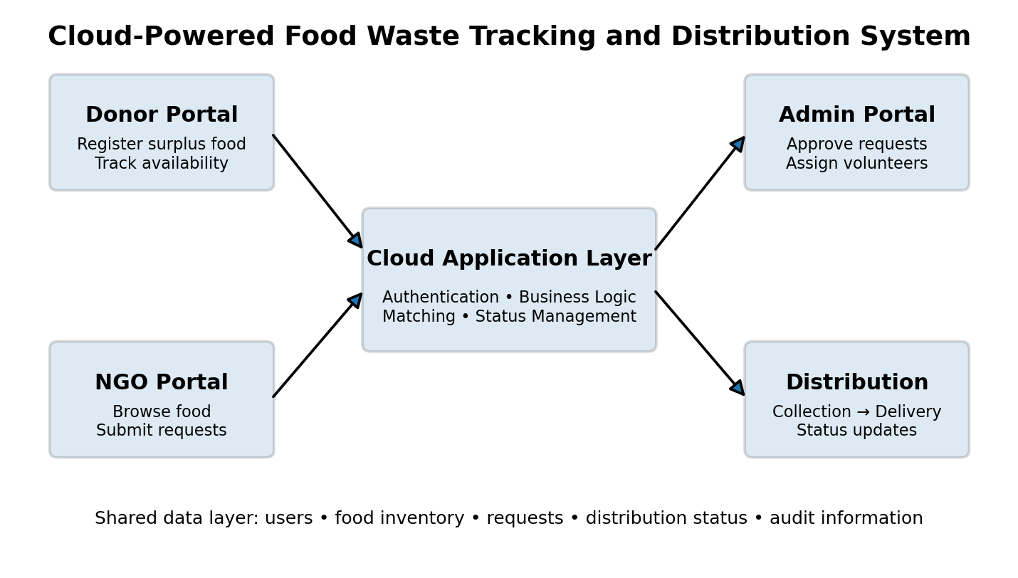
Figure 2. FoodShare Connect Workflow
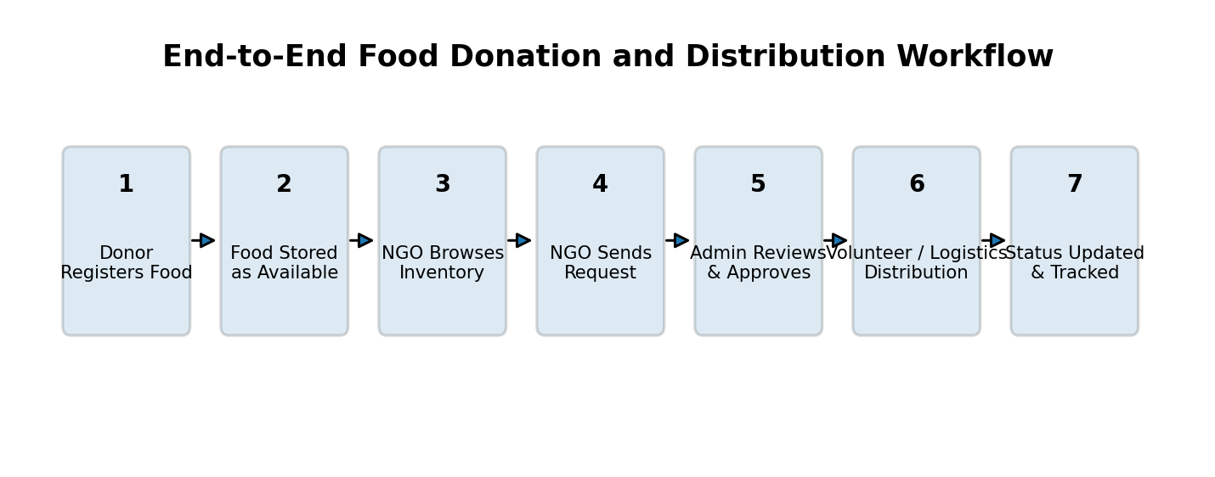
The architecture separates the user interface, application/API logic, database and deployment layer. The principal inventory calculation is Q_remaining = Q_available − Q_request. For the demonstrated biryani record, 150 packets were available and the NGO request was 100 packets, giving a logical remaining quantity of 50 packets if the request is approved and fully allocated. This is a calculation from the displayed data, not a measured system-performance result.
The frontend collects role-specific actions and sends them to the application layer. The application layer validates the user role, request values and workflow state before updating the database. The database acts as the shared source of truth for donation and request records. Administrative approval connects the request subsystem to inventory state, while volunteer assignment and distribution status provide the downstream operational stages.
  - Trade-off Analysis

Design Decision | Alternative Considered | Benefit | Disadvantage | Final Decision & Justification
Application architecture | Centralized web app vs mobile-first vs distributed services | Centralized design simplifies shared state and demonstration | Less independently scalable than microservices | Selected centralized web app because it best fits prototype scope and traceability requirement.

  - Sustainability, Ethics, Safety, Risk & Security

Domain | Consideration | Evidence Evaluated | Impact on Final Decision
Sustainability | Reduce avoidable surplus-food loss | Food-waste problem context; digital coordination reduces paper/manual duplication | Centralized digital records and matching workflow selected.
Ethics | Fair and traceable allocation | Role separation and admin approval requirement | Admin review retained instead of fully automatic allocation.
Health & Safety | Food is time-sensitive and may be unsafe if mishandled | FSSAI regulatory context and user-entered food information | System records information but does not claim to certify food safety.
Security | Prevent unauthorized access and data misuse | OWASP/NIST security guidance | Role-based access and validation treated as core requirements.
Risk Register

Risk | Likelihood | Severity | Risk Level | Mitigation | Residual Risk
Incorrect quantity entry | Medium | High | High | Input validation and admin review | Medium

CHAPTER 4

IMPLEMENTATION, TESTING & RESULTS, PROJECT MANAGEMENT

  - Development Approach & Resources

Development followed an incremental prototype approach. The workflow was first decomposed into roles and states, followed by database-oriented design, interface implementation, integration of donation and request flows, and functional verification using representative records. Screenshots were captured from the working prototype to provide evidence of the main user journeys. The supplied evidence does not include a formal production load test, penetration test or independently measured response-time study.
  - Hardware / Software / Fabrication Implementation & Modern Tools Used

The implementation is software-only. The demonstrated interface is a web application running in a local development environment, with a database-backed model for users, donations and requests. The prototype uses role-specific screens for donor, NGO and administrator activities. Cloud deployment is treated as the target architecture rather than as an already-measured production deployment.

Tool / Software / Equipment | Purpose | Stage Used
Web development environment | Build and run the FoodShare Connect prototype | Implementation and demonstration
The following implementation evidence is taken from the supplied FoodShare Connect screenshots. Together, the screens demonstrate authentication/registration, donor inventory creation, NGO discovery and request submission, and administrator request review.
Figure 3. FoodShare Connect Login Screen
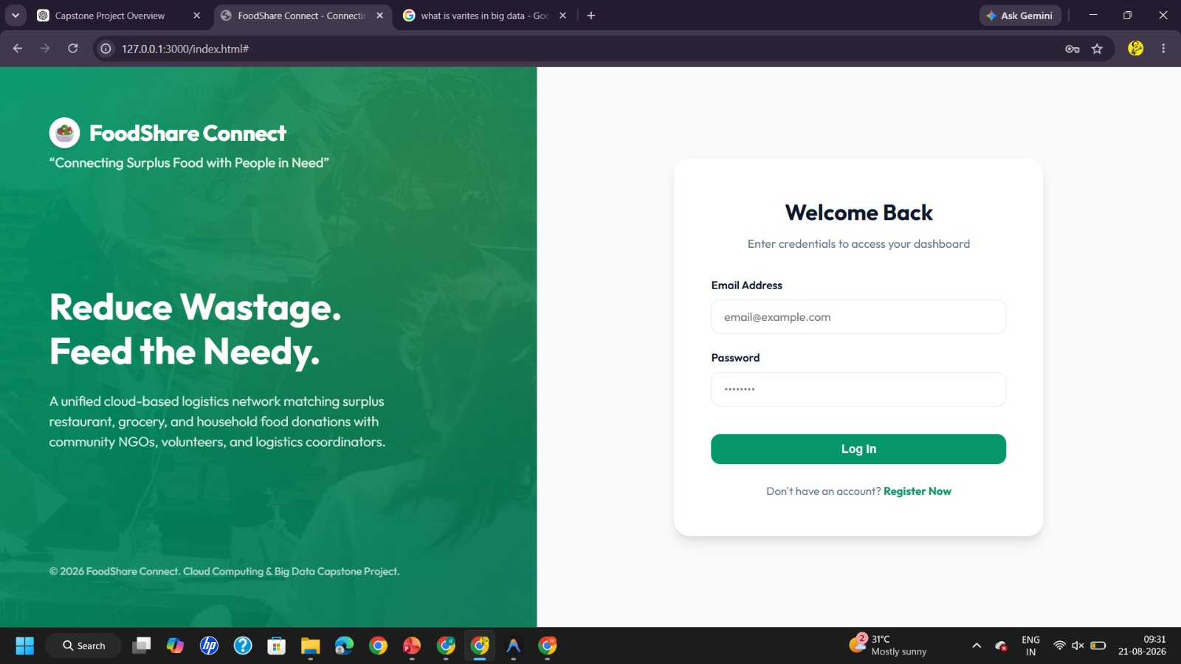
Figure 4. Donor Dashboard and Donation Status
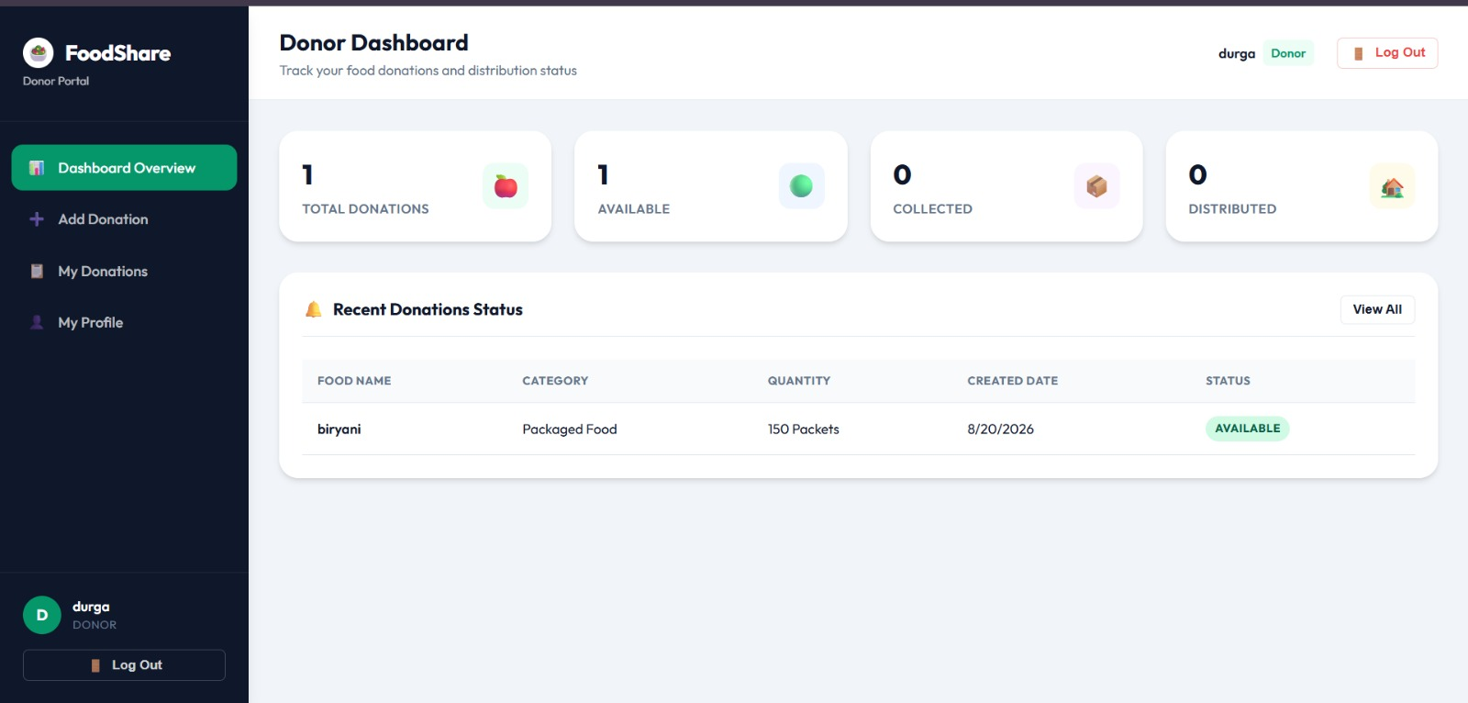
Figure 5. Administrator NGO Request Queue
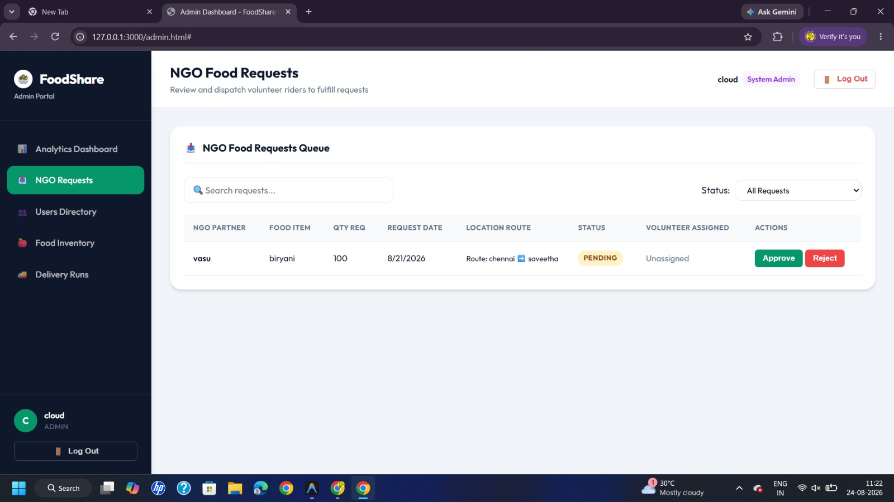
Figure 6. NGO Browse Available Food
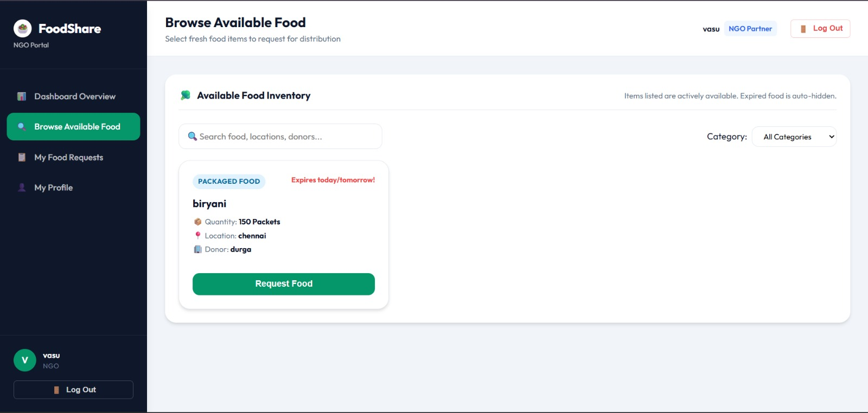
Figure 7. Registration and Role Selection
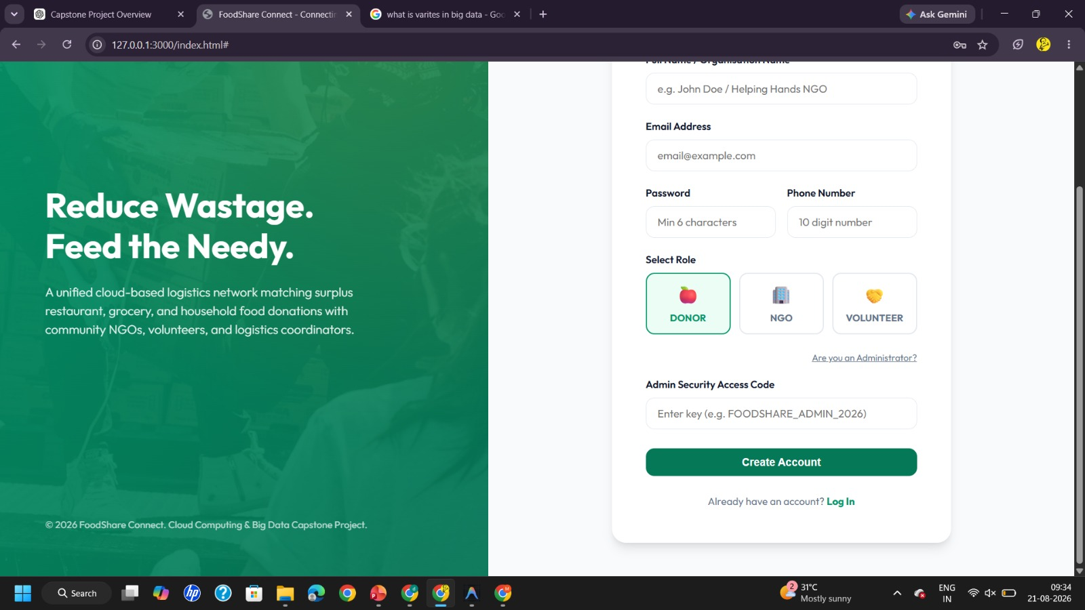

  - Test Plan & Verification

Requirement |  | Test Method |  | Acceptance Criterion
Record surplus food |  | Functional UI verification |  | Pass
NGO browsing | Open NGO browse screen |  | Available item is visible with donor/location |  | Pass
Request | Create NGO request |  | Request appears in admin queue |  | Pass
Admin review | Control pending request | Inspect request queue | Functional UI verification | Approve/Reject actions visible | Pass
  - Results

Functional results are reported from the supplied prototype evidence. The donor dashboard shows one recorded donation, one available item, zero collected and zero distributed. The donation is biryani, category Packaged Food, quantity 150 Packets, location Chennai and status AVAILABLE. The NGO browse screen shows the same 150-packet item and donor durga, while the administrator queue shows NGO vasu requesting 100 packets with PENDING status and no volunteer assigned.
  - Data Analysis & Engineering Judgment

The screenshots provide direct evidence that the core data objects are connected across roles: a donation becomes visible to an NGO, an NGO request enters an administrator queue, and the request retains quantity and route information. The 150-versus-100 quantity relationship is internally plausible for an allocation workflow, but approval and final distribution were not evidenced in the supplied screenshots. Therefore the strongest supported conclusion is functional workflow readiness, not production-scale performance.

  - Comparison with Existing Solutions & Achievement of Objectives

Objective | Evidence | Achievement (Fully/Partially/Not Achieved)
Role-based workflow | Registration/login and role-specific screens | Fully
  - Strengths & Limitations
Strengths | Limitations
• Clear separation of donor, NGO and administrator roles.  • Centralized view of food quantity, category, location and availability.  • Request approval workflow gives the administrator a control point. | • Response-time, throughput and scalability were not instrumented in the supplied evidence.  • No independent security audit or penetration-test report was supplied.  • Food quality is recorded through system fields; no automated sensing is demonstrated.
• Simple user journey from registration to donation browsing and request.  • Traceable status fields support monitoring of the donation lifecycle. | • The supplied evidence demonstrates a local prototype rather than a production deployment.  • Volunteer assignment and final distribution are only partially evidenced in the supplied screenshots.

  - Project Planning, Roles & Budget
Project milestones: Week 1 – problem definition and requirements; Week 2 – literature/standards review; Week 3 – architecture and database design; Weeks 4–5 – frontend/backend implementation; Week 6 – integration and functional testing; Week 7 – evidence capture and report preparation. Roles and costs are summarized in the tables below.
Student | Assigned Responsibility | Actual Contribution
K Sai Kumar (192365025) | Architecture, database, tracking | System planning, architecture, data model, workflow and testing
Kongara Sai (192365025) | UI and user-flow design | Registration/login, interface structure and usability
B Yogendra (192325046) | Donor and inventory module | Donation entry, inventory status and donor dashboard
G Venkatesh Reddy (192372262) | NGO request and matching | Available food browsing, requests and allocation logic
H Sanjay Reddy (192372056) | Admin, testing and documentation | Request review, status verification and report consolidation

CHAPTER 5

CONCLUSION, FUTURE WORK AND REFLECTION

  - Conclusion
FoodShare Connect demonstrates a practical software-engineering response to the coordination problem created by surplus food. The prototype connects donation recording, NGO discovery, request submission and administrator review through a shared workflow. The supplied screenshots validate the major user-facing stages and show consistent food and request data across roles. The project contributes a cloud-ready architecture and a documented engineering design while clearly distinguishing demonstrated functionality from future production validation.
  - Future Work
Future work should include hosted cloud deployment, stronger authentication and authorization, automated notifications, volunteer assignment and route optimization, food-safety checklists, audit logs, automated backups, monitoring, load testing and security testing. A production version should also integrate operational policies for collection windows, expiry information and responsible handling of food.

  - Professional Learning & Individual Reflection
New Knowledge Acquired: cloud-ready application architecture; role-based workflow design; database state modelling; software testing and evidence capture; security and software-quality considerations; documentation of engineering constraints and assumptions.
Engineering & Professional Skills Developed: requirements analysis, system design, database modelling, web development, integration testing, technical writing, teamwork, presentation and engineering decision-making. Individual reflections are recorded below.
K Sai Kumar (192365025) – I contributed to system planning, architecture and database design. The project improved my ability to convert a real coordination problem into a structured web-system workflow and strengthened my understanding of testing and technical documentation.
Kongara Sai (192365025) – I focused on the interface, authentication flow and user journey. This work helped me understand how clear navigation and role-based screens make a multi-user application easier to operate and validate.
B Yogendra (192325046) – I worked on donor-side donation and inventory functions. I learned how food records, quantities and availability states need to remain consistent so that later requests can be processed correctly.
G Venkatesh Reddy (192372262) – I worked on NGO browsing, request handling and allocation logic. This strengthened my understanding of matching available quantities with requests and documenting the reasoning behind system decisions.
H Sanjay Reddy (192372056) – I contributed to administration, testing and final documentation. The project improved my skills in checking workflows from an end-to-end perspective and presenting technical evidence in a clear engineering report.
    - Most difficult engineering problem encountered: keeping donation and request information understandable across different user roles. It was addressed by defining role-specific screens and explicit status fields so each actor sees only the workflow information relevant to the next decision.
    - Key engineering decision: use a centralized database-backed workflow for the prototype. The decision was supported by the need for a single consistent inventory record and by the limited scope of the academic demonstration.
    - New knowledge acquired independently: practical use of cloud-computing concepts, database-backed web workflows, security guidance and structured functional verification.
    - If repeated, the design would introduce stronger automated validation, explicit collection/distribution state transitions, audit logging and measurable performance testing earlier in development.

REFERENCES

References are presented in IEEE-style form and include literature, standards and official guidance used to frame the engineering design.
- [1] UNEP, “Food Waste Index Report 2024,” United Nations Environment Programme, 2024.
- [2] P. Mell and T. Grance, “The NIST Definition of Cloud Computing,” NIST SP 800-145, 2011.
- [3] OWASP Foundation, “OWASP Top 10: 2021,” 2021.
- [4] No external dataset was used in the supplied prototype evidence; representative application records were used for functional demonstration.
- [5] Project software stack and local development environment as implemented for the FoodShare Connect prototype.
- [6] OWASP Foundation, “Application Security Verification Standard (ASVS),” project guidance.
- [7] AI-assisted drafting was used as a documentation aid; project-specific claims in this report are restricted to the supplied prototype evidence and stated assumptions.

APPENDICES
Appendix A – Detailed Calculations
This appendix records the simple engineering calculations that can be derived directly from the supplied prototype evidence. The values describe the demonstrated donation and request workflow; they are not performance measurements.
Parameter | Value | Meaning
Q_available | 150 packets | Food quantity displayed as available on the donor/NGO screens.
Q_request | 100 packets | Quantity requested by the NGO in the administrator request queue.
Q_remaining | 50 packets | Quantity remaining if the full request is approved and deducted once.
Allocation ratio | 66.67% | 100 ÷ 150 × 100; share of available stock represented by the request.
Balance ratio | 33.33% | 50 ÷ 150 × 100; remaining share after the illustrated allocation.
Allocation equation: Q_remaining = Q_available − Q_request. Substitution for the demonstrated records gives 150 − 100 = 50 packets. A production system should additionally validate expiry, food condition, duplicate requests, concurrent updates and transaction atomicity before confirming an allocation.
Status logic used in the design: AVAILABLE → REQUESTED/PENDING → APPROVED → ASSIGNED → COLLECTED → DISTRIBUTED. The supplied screenshots directly evidence AVAILABLE and PENDING states; later states are included as the intended workflow states, not as observed completion evidence.
Appendix B – Engineering Drawings / Schematics
The system architecture and workflow drawings included in Chapter 3 are reproduced as the principal engineering schematics for this software prototype. They show the relationship between the user interface, application/API layer, database, role-based modules and donation/request lifecycle.
Drawing interpretation: the frontend captures role-specific actions; the backend/API validates and processes requests; persistent data stores retain users, donations, requests and status information; the administrator provides approval control; the NGO and donor interfaces expose only the information needed for their respective tasks.

Figure B.1 – Logical system architecture

Figure B.2 – End-to-end donation and request workflow
The diagrams are logical engineering representations of the demonstrated application. They should be treated as design documentation rather than evidence of a particular cloud vendor deployment.
Appendix C – Source Code / Code Repository Information
The complete source repository was not supplied as a file in this submission. Instead of inventing a public URL or unsupported code statistics, this appendix records the expected software organization and the implementation areas represented by the demonstrated screens.
Module | Primary responsibility | Evidence / report location
Frontend | Registration, login, donor dashboard, NGO browsing/request and administrator views. | Chapter 4 screenshots
Backend / API | Authentication, donation records, request processing, role-based operations and status updates. | Chapter 3 architecture and workflow
Database / schema | Users, roles, food donations, requests, quantities, locations and status fields. | Chapter 3 data model
Assets | Interface assets, diagrams and project media. | Report figures and project evidence
Tests | Functional checks for registration, donation creation, browsing, request submission and admin review. | Chapter 4 test plan
Deployment configuration | Environment variables, service configuration and future cloud deployment settings. | Future-work boundary
Recommended repository structure: frontend/, backend/, database/, assets/, tests/, docs/ and deployment/. Sensitive credentials should never be committed to the repository and should instead be stored through environment or secret-management facilities.
Appendix D – Datasheets
Because FoodShare Connect is a software-only prototype, conventional hardware datasheets are not applicable. The following software technical specification sheet records the important design parameters used by the prototype.
Component | Specification / role | Engineering consideration
User roles | Donor, NGO, Volunteer, Administrator | Role separation limits access to role-specific workflows.
Food record | Item, category, quantity, location, donor, status and date fields | Supports inventory visibility and traceability.
Request record | NGO, food item, requested quantity, route/date information and request status | Supports controlled approval.
Application interface | Web-based role-specific screens | Designed for straightforward data entry and review.
Data storage | Centralized application data model | Provides a single source of operational records.
Security baseline | Authentication, authorization, input validation and secure configuration guidance | Requires further hardening and audit before production use.
These specifications describe the demonstrated academic prototype and design intent. They are not a vendor certification or a claim of formal compliance with any external standard.
Appendix E – Experimental / Raw Data
The following evidence matrix preserves the observable values from the supplied prototype screenshots. It separates direct observations from derived engineering calculations.
Evidence item | Observed information | Interpretation
Donor dashboard | 1 total donation; 1 available; 0 collected; 0 distributed. | Donation exists and is currently available.
Donation record | Biryani; Packaged Food; 150 Packets; Chennai; AVAILABLE; created 8/20/2026. | Inventory record is visible to the donor.
NGO browse screen | Biryani; 150 Packets; Chennai; donor durga; Request Food. | Available inventory is exposed to an NGO.
Admin request queue | NGO vasu; biryani; 100 requested; 8/21/2026; Chennai → Saveetha; PENDING; volunteer unassigned. | Request reached administrator review.
Derived allocation | 150 − 100 = 50 packets. | Illustrative remaining quantity after full approval.
No response-time, throughput, load, energy, accuracy or processing-time dataset was supplied. Consequently, this appendix intentionally avoids fabricating numerical performance results.
Appendix F – Ethics / Institutional Approval
The project is a software engineering prototype for food-surplus coordination. The following ethics and safety checklist records the engineering controls considered during design.
• Food safety: the platform should record relevant food information and status but must not be treated as a substitute for food-safety inspection or applicable regulations.
• Privacy: user information should be limited to what is operationally required and protected through access control.
• Authorization: donor, NGO, volunteer and administrator actions should remain role-specific.
• Traceability: donation and request status changes should be recorded so that actions can be reviewed.
• Fairness: allocation decisions should use transparent request and approval rules rather than hidden preference.
• Safety escalation: unsafe, expired or unsuitable food should be rejected or removed from availability before distribution.
• Institutional status: no separate ethics approval document was supplied with the project evidence; therefore no approval number or institutional clearance is claimed.
This checklist is an engineering responsibility record, not a statement of regulatory certification.
Appendix G – Project Meeting / Progress Records
The report records a seven-week development sequence. The following progress record expands that sequence into a practical project log without inventing meeting dates or attendance details.
Stage | Progress activity | Output / decision
Week 1 | Problem definition and stakeholder identification. | Defined food-surplus tracking and distribution coordination problem.
Week 2 | Literature and standards review. | Identified cloud, software-quality, security, sustainability and food-safety guidance.
Week 3 | Architecture and data-model design. | Defined role separation, core entities, workflow states and allocation logic.
Weeks 4–5 | Frontend/backend implementation and integration. | Built the demonstrated registration, donor, NGO and administrator workflows.
Week 6 | Functional verification. | Checked data visibility, request flow and consistency across role screens.
Week 7 | Evidence capture and documentation. | Prepared screenshots, engineering diagrams, analysis and final report.
For future project iterations, each meeting record should include date, attendees, agenda, decisions, assigned actions, owner and completion status. Those fields are recommended controls rather than retrospective claims about meetings not documented in the supplied material.
Appendix H – User / Industry Feedback
No independently documented external industry evaluation was supplied. To keep the report evidence-based, the following is presented as an internal prototype review checklist rather than attributed feedback from a named external organization.
Review area | Observed / review point | Improvement action
Donor usability | Donation information is presented in a compact dashboard view. | Add clearer validation messages and edit/history controls.
NGO usability | Available food can be browsed and a request action is visible. | Add filters for category, quantity, location and expiry.
Administrator control | Pending requests expose quantity, route and approval actions. | Add confirmation dialogs, audit history and conflict checks.
Volunteer workflow | Volunteer assignment is represented but not fully evidenced in the supplied screens. | Add dedicated assignment, pickup and collection confirmation screens.
Distribution tracking | Final distribution state is part of the intended lifecycle. | Add proof-of-delivery and recipient confirmation fields.
These points are engineering review recommendations derived from the demonstrated workflow; they should not be presented as quotations or formal external-user survey results.
Appendix I – Publications / Patents / Competitions / Product Outcomes
The primary outcome represented by this submission is an academic software prototype and its engineering documentation. No patent, journal publication, competition award or commercial product claim is made.
Outcome category | Recorded outcome | Status
Academic prototype | FoodShare Connect prototype demonstrating donor, NGO and administrator workflow. | Demonstrated in supplied screenshots
Technical documentation | Architecture, workflow, requirements, testing, risk and sustainability documentation. | Included in this report
Publication | No publication record supplied. | Not claimed
Patent / IP filing | No patent filing record supplied. | Not claimed
Competition / award | No competition or award evidence supplied. | Not claimed
Product deployment | Prototype evidence is local; production deployment evidence was not supplied. | Future development
Potential future product outcomes include cloud deployment, location-based matching, notifications, analytics, demand prediction and stronger traceability. These are proposed extensions, not completed outcomes.

